FORMAT FOR PREPARATION OF MINI-PROJECT REPORT

ARRANGEMENT OF CONTENTS:

The sequence in which the project report material should be arranged and bound should be as follows:

  - Cover Page & Title Page
  - Bonafide Certificate
  - Acknowledgement
  - Abstract
  - Table of content
  - Objective
  - Description of the project
  - Output (Snap shot)
  - Results and discussion
  - Conclusion

* * * * *

SPECIMEN

PATIENT HEALTH MONITORING SYSTEM USING ESP32& WEBSERVER

PROJECT REPORT

Submitted by
BALAJI V 715522105009
JANATH J 715522105020
THARUN ADITHYA B 715522105053
SRIKANTH R 715522105311

DEPARTMENT OF

ELECTRICAL AND ELECTRONICS ENGINEERING



PSG INSTITUTE OF TECHNOLOGY AND APPLIED RESEARCH

Neelambur, Coimbatore 641 062

MAY 2024

PSG INSTITUTE OF TECHNOLOGY AND APPLIED RESEARCH

Neelambur, Coimbatore 641 062

BONAFIDE CERTIFICATE

Certified that this project report “PATIENT HEALTH MONITORING SYSTEM USING ESP32 & WEBSERVER”

is the bonafide work of “BALAJI V ; JANATH J ;
THARUN ADITHYA B ; SRIKANTH R ; ”

who carried out the mini project work under my supervision.

SIGNATURE SIGNATURE

Dr. Subashkumar C S Ms.K.Bavithra

HEAD OF THE DEPARTMENT SUPERVISOR
Associate Professor & HoD Assistant Professor (Senior Grade)
Department of Electrical and Department of Electrical and
Electronics Engineering Electronics Engineering
PSG Institute of Technology and PSG Institute of Technology and
Applied Research Applied Research

TABLE OF CONTENTS

Abstract

Sl. No. | TITLE | Page No.
1. | Objective | 1
2. | Description of the project | 1-16
3. | Output (Snap shot) | 17
4. | Results and Discussion | 18
5. | Conclusion | 18

Objective

This project presents a comprehensive patient health monitoring system utilizing an ESP32 microcontroller interfaced with various sensors and a webserver for real-time data visualization and alert management. The system monitors vital health parameters, including heart rate and SpO2 using the MAX30100 sensor, body temperature using the DS18B20 sensor, and room temperature and humidity using the DHT11 sensor. Additionally, it controls the room temperature through a relay system, which activates a heating mechanism when the body temperature falls below 37°C.

Algorithm :

- Initialize ESP32, sensors, and webserver.

- Continuously read data from MAX30100, DS18B20, and DHT11.

- Display data on the webserver.

- Check if body temperature (DS18B20) is below 37°C.
If true, activate the relay to turn on the heating mechanism.
If false, deactivate the relay.

- Update the webserver with the latest data and system status.

Description of the Project

Components Used :

- ESP32

- MAX30100

- DS18B20

- DHT11

- Relay Module

Components Function :

ESP32 :

Central controller for processing and communication.

MAX30100 :

The MAX30100 is an integrated pulse oximetry and heart-rate monitor sensor. It uses photodetectors, LEDs, and low-noise electronics with ambient light rejection to derive the heart rate and SpO2 levels.

DS18B20 :

The DS18B20 is a digital temperature sensor with high accuracy and a wide operating temperature range. It measures the body temperature of the patient and provides data via a 1-Wire interface.

DHT11 :

The DHT11 is a basic, low-cost digital sensor for measuring temperature and humidity.

Relay Module :

A relay module is used to control external devices. In this system, it activates a heating mechanism when the body temperature drops below 37°C to ensure the patient remains in a comfortable and safe temperature range.
Components Description :

ESP32 Specifications :
The ESP32 is a popular microcontroller developed by Espressif Systems, known for its versatility and performance. Here are the key specifications of the ESP32:

Microcontroller
- Core: Dual-core or single-core Tensilica Xtensa LX6
- Clock Speed: Up to 240 MHz
- Performance: Up to 600 DMIPS (Dhrystone Million Instructions Per Second)
- ROM: 448 KB
- SRAM: 520 KB
- Flash: Varies, commonly 4 MB or 8 MB

Connectivity
- Wi-Fi: 802.11 b/g/n, HT40, up to 150 Mbps, WEP, WPA/WPA2 authentication
- Bluetooth: v4.2 BR/EDR and BLE (Bluetooth Low Energy)

Peripherals
- GPIO: 34 programmable GPIOs
- ADC: 12-bit SAR ADC up to 18 channels
- DAC: 8-bit DAC, 2 channels
- I2C: 2
- I2S: 2
- SPI: 4
- UART: 3
- PWM: Available on all GPIO pins
- Touch Sensors: 10 capacitive touch GPIOs
- Temperature Sensor: Integrated

Power Management
- Operating Voltage: 2.2V to 3.6V
- Power Modes: Active mode, sleep mode, deep sleep mode, hibernation mode

Other Features
- Security: Hardware cryptographic acceleration (AES, SHA-2, RSA, ECC, HMAC)
- Integrated Hall Sensor
- Integrated Temperature Sensor
- RTC (Real-Time Clock)

Development
- Programming Languages: C, C++, MicroPython, Lua, JavaScript (NodeMCU)
- Development Environments: Arduino IDE, PlatformIO, Espressif IDF (IoT Development Framework)
The ESP32 is widely used in various applications such as IoT devices, home automation, wearable electronics, and more due to its rich set of features and powerful processing capabilities.
MAX30100 Specifications :
The MAX30100 is an integrated pulse oximeter and heart-rate sensor solution. Here are its key specifications:

Sensor Characteristics
- Photodetectors: Integrated red and infrared (IR) LEDs
- ADC Resolution: 16-bit

Key Features
- Pulse Oximetry: Measures SpO2 (blood oxygen saturation level)
- Heart Rate Monitoring: Measures heart rate (beats per minute)

Performance
- Operating Voltage: 1.8V and 3.3V power supplies
- Current Consumption:
  - Low Power Heart Rate Monitor Mode: 600 μA (typical)
  - Low Power SpO2 Mode: 1.1 mA (typical)
  - Shutdown Mode: 0.7 μA (typical)

Communication
- Interface: I²C (Inter-Integrated Circuit) digital communication
- Data Rates: Supports standard (100 kHz) and fast (400 kHz) I²C modes

Operating Conditions
- Temperature Range: -40°C to +85°C

Additional Features
- Low Power Consumption: Optimized for battery-operated devices
- Integrated Ambient Light Rejection: Minimizes the impact of external light
- Programmable Sample Rate and LED Pulse Width: Allows customization for different applications
- Built-in Temperature Sensor: Provides additional data for compensation algorithms

Applications
- Wearable Health Devices: Smartwatches, fitness bands
- Medical Monitoring: Portable medical devices
- Fitness Equipment: Treadmills, exercise bikes
The MAX30100 is designed for use in various applications that require accurate and low-power heart rate and SpO2 monitoring.

DS18B20 Specifications :
The DS18B20 is a popular digital thermometer with a 1-Wire communication interface. Here are its key specifications:

Sensor Characteristics
- Temperature Range: -55°C to +125°C (-67°F to +257°F)
- Accuracy:
  - ±0.5°C accuracy from -10°C to +85°C
  - ±2°C outside this range

Resolution
- Temperature Resolution: User-configurable to 9, 10, 11, or 12 bits
  - 9-bit: 0.5°C increments
  - 10-bit: 0.25°C increments
  - 11-bit: 0.125°C increments
  - 12-bit: 0.0625°C increments

Power Supply
- Operating Voltage: 3.0V to 5.5V
- Power Consumption:
  - Active Mode: 1 mA (max)
  - Standby Mode: 750 nA (typical)

Communication
- Interface: 1-Wire bus (requires only one data line and ground for communication)
- Unique 64-bit Serial Code: Each device has a unique 64-bit serial code, allowing multiple devices on the same 1-Wire bus

Additional Features
- Parasitic Power Mode: Can derive power directly from the data line, eliminating the need for an external power supply
- Programmable Resolution: Allows for trade-off between resolution and conversion time
- Alarm Function: Programmable upper and lower trigger points to signal when the temperature goes outside the set range
- Scratchpad Memory: 9 bytes of SRAM for storing temperature, configuration, and user data
- Operating Temperature: -55°C to +125°C

Applications
- Thermometers: Digital thermometers
- HVAC Systems: Heating, ventilation, and air conditioning systems
- Thermal Monitoring: Servers and computer systems
- Consumer Electronics: Appliances and consumer products
The DS18B20 is widely used for temperature measurement in various applications due to its simplicity, accuracy, and ease of integration with microcontrollers and other digital systems.

DHT11 Specifications :
The DHT11 is a basic, low-cost digital temperature and humidity sensor. Here are its key specifications:

Sensor Characteristics

Temperature
- Range: 0°C to 50°C
- Accuracy: ±2°C
- Resolution: 1°C

Humidity
- Range: 20% to 90% RH (Relative Humidity)
- Accuracy: ±5% RH
- Resolution: 1% RH

Electrical Characteristics
- Operating Voltage: 3.3V to 5.5V
- Max Current Consumption: 2.5 mA during measurement
- Standby Current: 100-150 μA

Communication
- Interface: Single-wire digital serial interface
- Data Transmission: 40-bit data stream (8-bit humidity integer data + 8-bit humidity decimal data + 8-bit temperature integer data + 8-bit temperature decimal data + 8-bit checksum)

Timing
- Sampling Period: Minimum 1 second (1 Hz)

Physical Characteristics
- Dimensions: 15.5 mm x 12 mm x 5.5 mm (approx.)

Additional Features
- Simple Communication Protocol: Easy to integrate with microcontrollers and development boards like Arduino and Raspberry Pi.
- Pre-calibrated: Comes with calibration coefficients stored in the onboard memory.
- Compact and Low-cost: Suitable for basic environmental sensing applications.

Applications
- HVAC Systems: Heating, ventilation, and air conditioning systems.
- Weather Stations: Basic weather monitoring devices.
- Home Automation: Smart home devices for monitoring environmental conditions.
- Consumer Electronics: Appliances requiring basic temperature and humidity sensing.
The DHT11 is widely used for simple projects and applications where basic temperature and humidity monitoring is required. Its ease of use and low cost make it popular for DIY electronics and educational purposes.
Relay Module Specifications :
Relay modules are widely used in electronic and electrical applications to control high voltage and high current devices with low voltage signals. Here are the typical specifications of a standard single-channel relay module:

Electrical Characteristics
- Coil Voltage: 5V DC (common for many relay modules, though 12V and 24V versions are also available)
- Control Signal Voltage:
  - Low-level trigger: 0-1.5V
  - High-level trigger: 2.5-5V
- Switching Voltage:
  - AC: 250V @ 10A (maximum)
  - DC: 30V @ 10A (maximum)

Power Consumption
- Coil Current: Approximately 70-100 mA when activated

Control Side
- Trigger Type: Can be either active high or active low, depending on the relay module design
- Control Pin: Usually requires a digital signal from a microcontroller (e.g., Arduino, Raspberry Pi)

Mechanical Characteristics
- Dimensions: Varies, but a typical single-channel relay module might be around 50mm x 26mm x 18.5mm
- Weight: Varies, generally around 20-30 grams

Features
- Optocoupler Isolation: Many relay modules use optocouplers to provide electrical isolation between the control (low voltage) side and the relay (high voltage) side, enhancing safety.
- Indicator LED: An onboard LED usually indicates when the relay is activated.
- Terminals:
  - Control Side: VCC, GND, and IN (signal pin)
  - Relay Side: COM (common), NO (normally open), and NC (normally closed)

Applications
- Home Automation: Controlling lights, fans, and other appliances.
- Industrial Automation: Switching motors, solenoids, and other industrial devices.
- DIY Projects: Custom electronics projects requiring control of high power devices.
- Automotive Applications: Controlling various automotive electronic devices.

Example Specifications of a Common Relay Module (5V Single-Channel)
- Relay Type: Songle SRD-05VDC-SL-C (or similar)
- Control Voltage: 5V
- Trigger Voltage: 0V (low level) or 5V (high level), depending on design
- Switching Capacity: 250VAC/10A, 30VDC/10A
- Isolation: Optocoupler isolated input
- Indicator: LED indicator for relay status
Relay modules are versatile and essential components for controlling high-power devices safely and effectively in various applications.
Circuit Diagram :

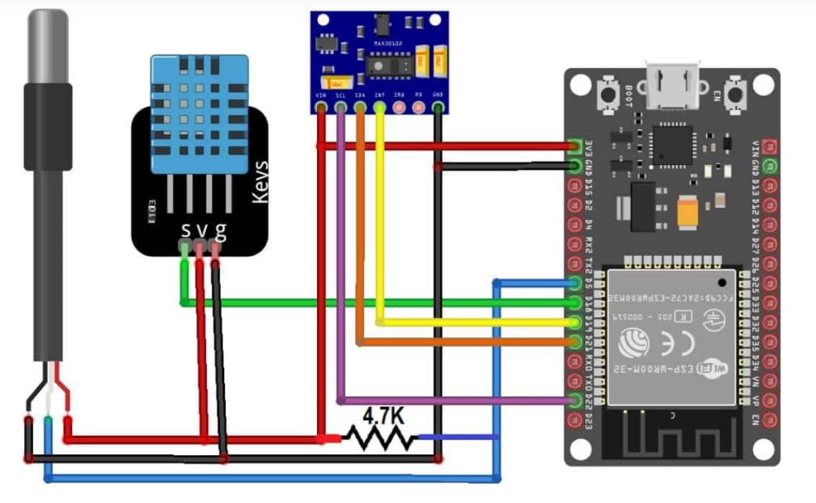

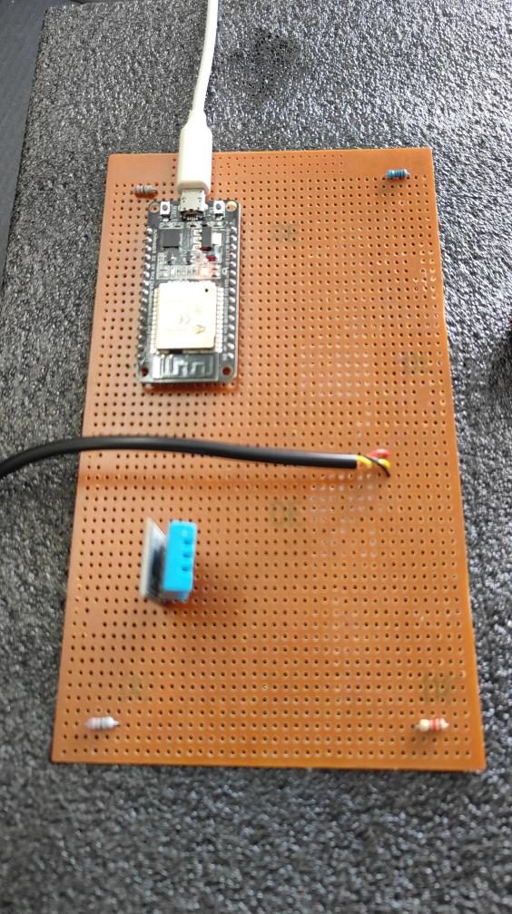

Output :

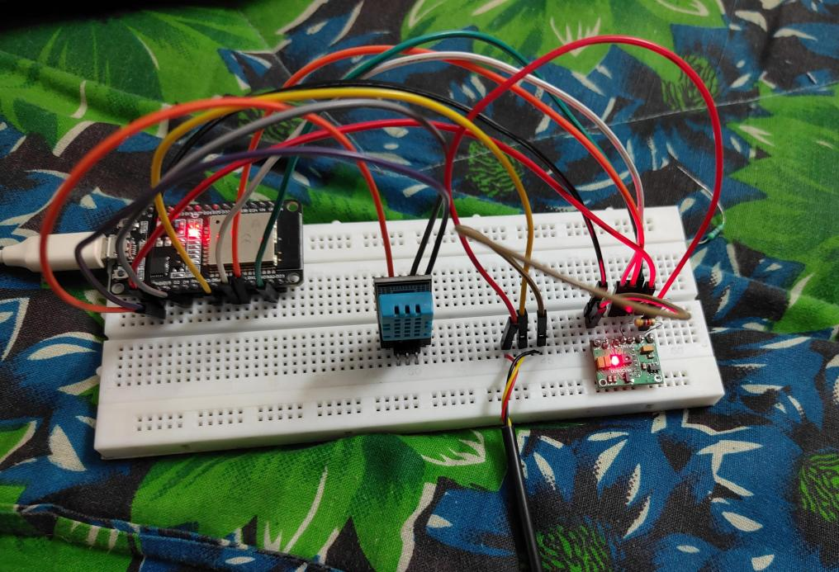

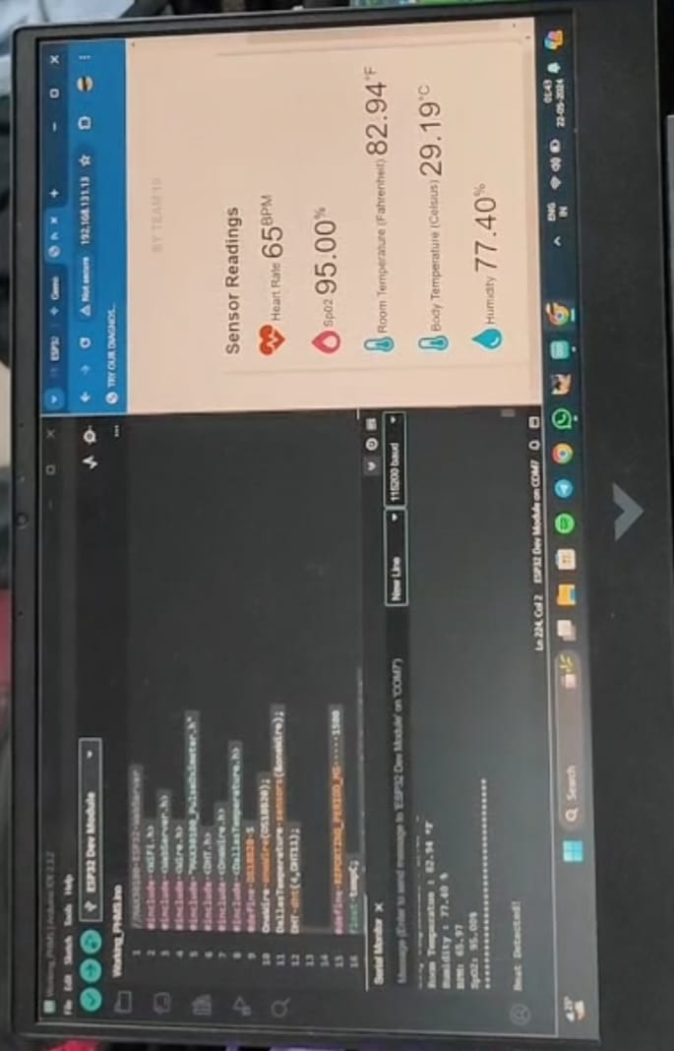

Results and Discussion :

The system was tested in a controlled environment to monitor its performance. The ESP32 successfully read data from all sensors and displayed it on the webserver. The relay activation based on body temperature conditions was reliable, ensuring that the patient's environment was maintained within safe temperature limits.

Bill of Materials Used :

S. No. | Materials | Quantity | Cost
1. | ESP 32 | 1 | 550
2. | MAX30100 Sensor | 1 | 250
3. | DS18B20 (body) Temperature Sensor | 1 | 150
4. | DHT 11 Sensor (room)  Temperature and Humidity | 1 | 150
5. | Relay | 1 | 120
6. | Filament bulb with holder | 1 | 230
7. | Jumper Wires | As required
 |  | TOTAL | 1500

Conclusion :

This patient health monitoring system using ESP32 and a webserver provides a reliable solution for real-time health monitoring and management. The integration of various sensors ensures comprehensive monitoring of vital signs and environmental conditions, while the webserver enables remote monitoring and alert management, enhancing patient care and safety.

Program :

//MAX30100 ESP32 WebServer
#include <WiFi.h>
#include <WebServer.h>
#include <Wire.h>
#include "MAX30100_PulseOximeter.h"
#include <DHT.h>
#include <OneWire.h>
#include <DallasTemperature.h>
#define DS18B20 5
OneWire oneWire(DS18B20);
DallasTemperature sensors(&oneWire);
DHT dht(4,DHT11);
#define relay1 2

#define REPORTING_PERIOD_MS 1500
float tempC;
float tempF; // Declare as global variable
float humidity; // Declare as global variable
float BPM, SpO2;
float F;

/*Put your SSID & Password*/
const char* ssid = "OnePlus Nord CE 3 5G"; // Enter SSID here
const char* password = "63645577"; //Enter Password here

PulseOximeter pox;
uint32_t tsLastReport = 0;

WebServer server(80);

void onBeatDetected()
{
Serial.println("Beat Detected!");
}

void setup() {
Serial.begin(115200);
dht.begin();
sensors.begin();
pinMode(19, OUTPUT);
pinMode(relay1, OUTPUT);
delay(100);
Serial.println("Connecting to ");
Serial.println(ssid);

//connect to your local wi-fi network
WiFi.begin(ssid, password);

//check wi-fi is connected to wi-fi network
while (WiFi.status() != WL_CONNECTED) {
delay(1000);
Serial.print(".");
}
Serial.println("");
Serial.println("WiFi connected..!");
Serial.print("Got IP: ");
Serial.println(WiFi.localIP());

server.on("/", handle_OnConnect);
server.onNotFound(handle_NotFound);

server.begin();
Serial.println("HTTP server started");
if (!pox.begin()) {
for (;;);
} else {
pox.setOnBeatDetectedCallback(onBeatDetected);
}

pox.setIRLedCurrent(MAX30100_LED_CURR_7_6MA);
}
void loop() {
server.handleClient();
sensors.requestTemperatures();
tempC = sensors.getTempCByIndex(0);
F=(tempC*9/5)+32;
tempF = dht.readTemperature(true);
humidity = dht.readHumidity();
if (tempC < 37) { // Check if temperature is less than 36 degrees
digitalWrite(relay1, HIGH); // Turn on relay
} else {
digitalWrite(relay1, LOW); // Turn off relay
}
pox.update();
BPM = pox.getHeartRate();
SpO2 = pox.getSpO2();

if (millis() - tsLastReport > REPORTING_PERIOD_MS)
{
Serial.print("Body Temperature : ");
Serial.print(F);
Serial.println(" *F");

Serial.print("Room Temperature : ");
Serial.print(tempF);
Serial.println(" *F");

Serial.print("Humidity : ");
Serial.print(humidity);
Serial.println(" %");

Serial.print("BPM: ");
Serial.println(BPM);

Serial.print("SpO2: ");
Serial.print(SpO2);
Serial.println("%");

Serial.println("*********************************");
Serial.println();

tsLastReport = millis();
}

}

void handle_OnConnect() {
server.send(200, "text/html", SendHTML(BPM, SpO2, tempF, F, humidity));
}

void handle_NotFound() {
server.send(404, "text/plain", "Not found");
}

String SendHTML(float BPM, float SpO2, float tempF, float F, float humidity) {
String ptr = "<!DOCTYPE html>";
ptr += "<html>";
ptr += "<head>";
ptr += "<title>Pulse Oximeter ESP32 WebServer</title>";
ptr += "<meta name='viewport' content='width=device-width, initial-scale=1.0'>";
ptr += "<link rel='stylesheet' href='https://cdnjs.cloudflare.com/ajax/libs/font-awesome/5.7.2/css/all.min.css'>";
ptr += "<link rel='stylesheet' type='text/css' href='styles.css'>";
ptr += "<style>";
ptr += "body { background-color: #fff; font-family: sans-serif; color: #333333; font: 14px Helvetica, Bree-serif box-sizing: border-box;}";
ptr += "#page { margin: 20px; background-color: #fff;}";
ptr += ".container { height: inherit; padding-bottom: 20px;}";
ptr += ".header { padding: 20px;}";
ptr += ".header h1 { padding-bottom: 0.3em; color: #008080; font-size: 45px; font-weight: bold; font-family: Garmond, 'sans-serif'; text-align: center;}";
ptr += "h2 { padding-bottom: 0.2em; border-bottom: 1px solid #eee; margin: 2px; text-align: left;}";
ptr += ".header h3 { font-weight: bold; font-family: Arial, 'sans-serif'; font-size: 17px; color: #b6b6b6; text-align: center;}";
ptr += ".box-full { padding: 20px; border 1px solid #ddd; border-radius: 1em 1em 1em 1em; box-shadow: 1px 7px 7px 1px rgba(0,0,0,0.4); background: #fff; margin: 20px; width: 300px;}";
ptr += "@media (max-width: 494px) { #page { width: inherit; margin: 5px auto; } #content { padding: 1px;} .box-full { margin: 8px 8px 12px 8px; padding: 10px; width: inherit;; float: none; } }";
ptr += "@media (min-width: 494px) and (max-width: 980px) { #page { width: 465px; margin 0 auto; } .box-full { width: 380px; } }";
ptr += "@media (min-width: 980px) { #page { width: 930px; margin: auto; } }";
ptr += ".sensor { margin: 12px 0px; font-size: 2.5rem;}";
ptr += ".sensor-labels { font-size: 1rem; vertical-align: middle; padding-bottom: 15px;}";
ptr += ".units { font-size: 1.2rem;}";
ptr += "hr { height: 1px; color: #eee; background-color: #eee; border: none;}";
ptr += "</style>";

//Ajax Code Start
ptr += "<script>\n";
ptr += "setInterval(loadDoc,1500);\n";
ptr += "function loadDoc() {\n";
ptr += "var xhttp = new XMLHttpRequest();\n";
ptr += "xhttp.onreadystatechange = function() {\n";
ptr += "if (this.readyState == 4 && this.status == 200) {\n";
ptr += "document.body.innerHTML =this.responseText}\n";
ptr += "};\n";
ptr += "xhttp.open(\"GET\", \"/\", true);\n";
ptr += "xhttp.send();\n";
ptr += "}\n";
ptr += "</script>\n";
//Ajax Code END

ptr += "</head>";
ptr += "<body>";
ptr += "<div id='page'>";
ptr += "<div class='header'>";
ptr += "<h1>Patient Health Monitoring System ESP32 WebServer</h1>";
ptr += "<h3>BY TEAM 10</h3>";
ptr += "</div>";
ptr += "<div id='content' align='center'>";
ptr += "<div class='box-full' align='left'>";
ptr += "<h2>Sensor Readings</h2>";
ptr += "<div class='sensors-container'>";

//For Heart Rate
ptr += "<p class='sensor'>";
ptr += "<i class='fas fa-heartbeat' style='color:#cc3300'></i>";
ptr += "<span class='sensor-labels'> Heart Rate </span>";
ptr += (int)BPM;
ptr += "<sup class='units'>BPM</sup>";
ptr += "</p>";
ptr += "<hr>";

//For Sp02
ptr += "<p class='sensor'>";
ptr += "<i class='fas fa-burn' style='color:#f7347a'></i>";
ptr += "<span class='sensor-labels'> Sp02 </span>";
ptr += (float)SpO2;
ptr += "<sup class='units'>%</sup>";
ptr += "</p>";
ptr += "<hr>";

// For Room Temperature (in Fahrenheit)
ptr += "<p class='sensor'>";
ptr += "<i class='fas fa-thermometer-half' style='color:#0099cc'></i>";
ptr += "<span class='sensor-labels'> Room Temperature (Fahrenheit) </span>";
ptr += (float)tempF;
ptr += "<sup class='units'>&deg;F</sup>";
ptr += "</p>";
ptr += "<hr>";

// For Body Temperature (in Celsius)
ptr += "<p class='sensor'>";
ptr += "<i class='fas fa-thermometer-half' style='color:#0099cc'></i>";
ptr += "<span class='sensor-labels'> Body Temperature (Fahrenheit) </span>";
ptr += (float)F;
ptr += "<sup class='units'>&deg;F</sup>";
ptr += "</p>";
ptr += "<hr>";

// For Humidity
ptr += "<p class='sensor'>";
ptr += "<i class='fas fa-tint' style='color:#0099cc'></i>";
ptr += "<span class='sensor-labels'> Humidity </span>";
ptr += (float)humidity;
ptr += "<sup class='units'>%</sup>";
ptr += "</p>";

ptr += "</div>";
ptr += "</div>";
ptr += "</div>";
ptr += "</div>";
ptr += "</body>";
ptr += "</html>";
return ptr;
}

